Camera HD

Sense-U® Video Camera (New): Connection Issues

Steps to troubleshoot connection issues:
1. Move your Sense-U device close to your WiFi router and make sure you are able to connect to internet.
2. Verify the WiFi password has not been changed recently.
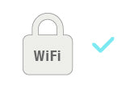
3. Switch your smartphone to cellular plan to see if it is able to stream the video.

4. If the indicator light is solid RED, it means the camera is not able to connect to internet. Check your network connection and WiFi password.
5. If still not working, delete the camera from your current account and register the latest iOS app(3.1.2) with a NEW email address to pair the camera again. It will connect your camera to a closer server to improve connection performance.
* If still no luck, refer to the latest user manual or contact us from the Sense-U App->Setup->Help->Feedback.

Sense-U® Video Camera (New): Pairing Issues

Steps to troubleshoot pairing issues:
- Make sure the selected WiFi network is 2.4G private WiFi network, and is not a public WiFi network requiring credential login on a web portal like the ones at airport.
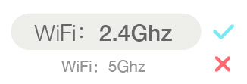
2. Verify the entered Wi-Fi password is right.
- If the indicator is flashing RED and GREEN, it implies weak Wi-Fi signal or crowded network situation. Move your Sense-U device close to your Wi-Fi router and make sure you are able to connect to internet.

- If the indicator light is solid GREEN after pairing, but the App doesn't stream video as expected, please log out and log in again to reload the video stream.

"Unrecognized QR code" Error:
- Make sure the selected Wi-Fi network is 2.4G private Wi-Fi network, and is not a public Wi-Fi network requiring credential login on a web portal like the ones at airport.
- Ensure the lens is not blocked and clean. Move to a brighter place and adjust the brightness of your smartphone to maximum. Place the app QR code in front of the video camera at a distance of 6”-12”(15cm-30cm). Adjust the angle and distance until you hear a prompt.
- Alternatively, try Auto Scan method: “Try Auto Scan ->” (Available for iOS App now)
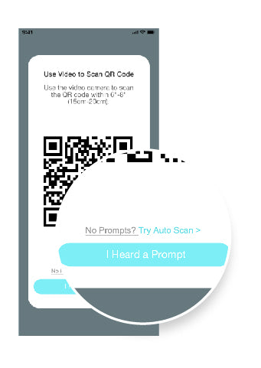
- If you are using a Wi-Fi 6 router with single network ID (SSID), make sure to unselect "SMART CONNECT" from your router's web interface or app, and then choose the 2G SSID to pair:
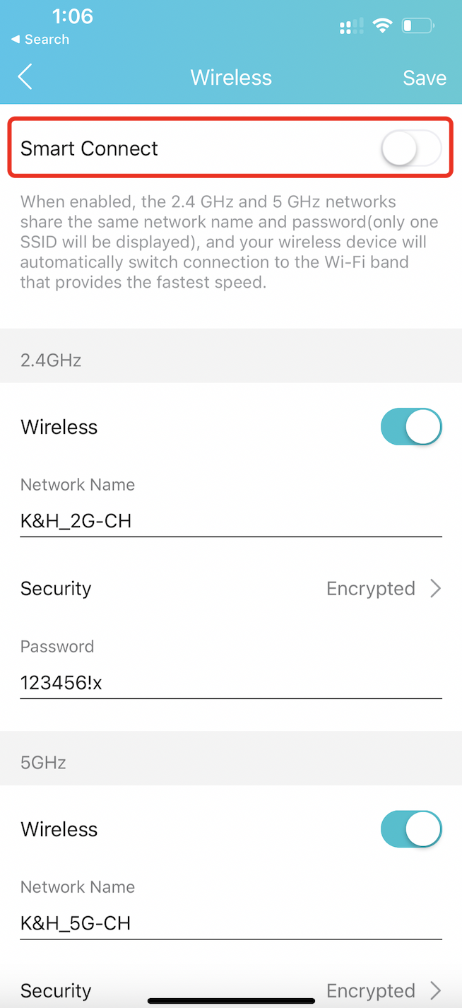
(e.g: TP-Link Tether App)
Tips: Where to find Smart Connect for typical routers:
- Tp-Link Wi-Fi 6: https://www.tp-link.com/us/support/faq/2595/
- Netgear Wi-Fi 6: https://kb.netgear.com/25346/
- Amazon Eero - Temporarily pause 5GHz: https://support.eero.com/hc/en-us/articles/115005497223/
- Aus Wi-Fi 6: https://www.asus.com/us/support/FAQ/1012132/

Sense-U® Video Monitor (New) - User Manual

READ ME FIRST
- The Sense-U Video camera, and the Sense-U Smart Baby Monitor are not medical devices, and are not intended for use in the diagnosis of disease or other conditions, or in the cure, mitigation, treatment, or prevention of disease.
- Only 2.4GHz private Wi-Fi networks are supported. Hotspot Wi-Fi and 5GHz Wi-Fi are not supported.
- Make sure your mobile device is running iOS 9.0 & up, or Android 4.3 & up.
- Enter correct Wi-Fi network ID, password and make sure your mobile device in the same Wi-Fi network before pairing to the Sense-U Video camera.
- If the indicator light keeps flashing GREEN after pairing, most likely the Wi-Fi password or network connection is not right; If the indicator light is solid GREEN after pairing, log out and log in again to update the status of the Video camera.
- To pair a connected Sense-U Video camera to a new account, you need to delete it first by tapping “Delete” button from the Sense-U Baby App->Video Device Settings (setup icon on the home page)->Delete first.
- For audible notifications, notifications need to switch on for the Sense-U Baby app in Settings->Notifications->Sense-U Baby. For Android device, make sure Media Volume is switched on in Settings->Sounds and Vibration->Volume. For iOS device, make sure your mobile device is not in Do Not Disturb mode.
- For two-way audio, please turn on the camera and microphone permissions in Settings->Apps->Sense-U Baby->Microphone & Camera and tap speaker and microphone icons in the app to enable it.
- DO NOT adhere the Sense-U Video camera on a ROUGH wall in case it falls and hurts your child.

INTRODUCTION
- Intended Use
The Sense-U Video camera lets you see, hear, and talk to your child from anywhere. Together with the award-winning Sense-U Smart Baby Monitor, you can monitor your child’s sleep quality indicators including body movement, sleeping position and temperature while streaming HD video to your smartphone, anytime, anywhere.
- System Requirements
Smart Devices running iOS 9.0 & up, and Android 4.3 & up
- G Wi-Fi Network (Hotspot Wi-Fi and 5G Wi-Fi are not supported)
- Technical Specifications
Resolution: HD 1080P (1920x1080)
Field of View: 93o Diagonal
Audio: Internal Speaker and Microphone
Storage: Up to 128G High Speed Micro SD Card (not included)
Communication: 2.4GHz Wi-Fi (not compatible with hotspot and 5GHz Wi-Fi networks)
- What’s in the Box
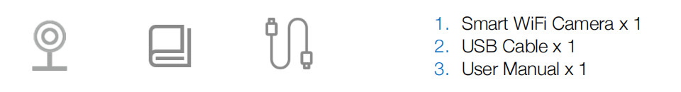

OPERATIONS

Download the Sense-U Baby App and Register an Account
Download the free Sense-U Baby app for iOS and Android, register a free Sense-U account, and pair with your Sense-U device following the instructions in the app.


Installation
STEP 1: Plug in the USB charging cable and make sure the indicator light on the device is flashing RED, indicating the device is ready to pair.
If not, follow the instructions below to reset the device.
How to reset the device?
•Use the reset pin to press the Reset button for 5+ seconds until the camera starts to beep.
STEP 2 (Optional): Insert an 8-64GB high-speed Micro SD card into the SD card slot to store, replay historical videos.
STEP 3: Place the Video camera on a flat surface or adhere it on a wall above a crib.
* DO NOT adhere the Video camera on a ROUGH wall in case it falls and hurts your child.
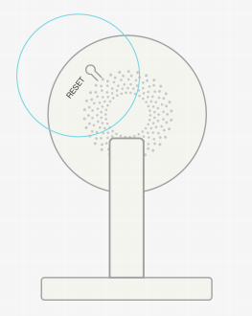

Choose Device
For new user, choose “Sense-U Video” device from “Choose Device” page to pair.
For existing user, tap “Delete” button in the Sense-U Baby App->Video Device Settings (setup icon on the home page)->Delete from the connected account to delete and/or re-sync current device.
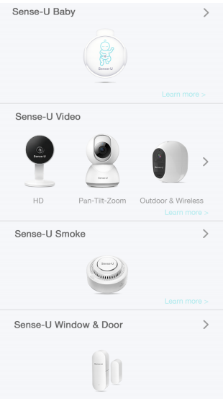

Pair Device
Enter your Wi-Fi network and password and tap “Confirm” to pair. The device will beep, turn to solid GREEN when it is paired successfully.
The device will beep once when it is paired successfully. Then click “I Heard a Prompt”.
If it is unable to pair, here is a checklist:
- If the indicator light keeps flashing GREEN after pairing, most likely the Wi-Fi password or network connection is not right;
- If the indicator light is solid GREEN after pairing, log out and log in again to update the status of the Video camera.
- If the indicator is flashing RED and GREEN, it implies weak Wi-Fi signal or crowded network situation. Move your Sense-U device close to your Wi-Fi router and make sure you are able to connect to internet.
- If you get the “Unable to pair” message and error bar code, please send us the bar code to us to reactivate the Video Camera.
* 2.4GHz private Wi-Fi network is required. 5G Wi-Fi and hotspot Wi-Fi networks are not supported.
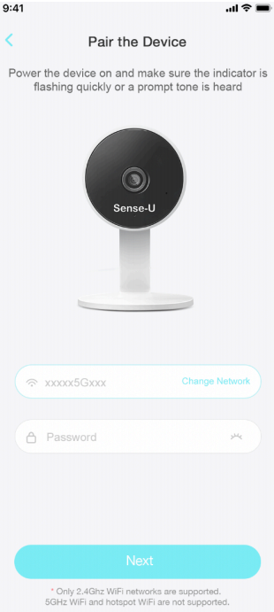

Pairing a Connected Device to New Account
To pair a connected device to a new Sense-U account, the device needs to be unpaired first by tapping “Delete” button from the Sense-U Baby App->Video Device Settings (setup icon on the home page)->Delete first.
* Alternatively, send us an email with the error bar code you received to reactivate the device.
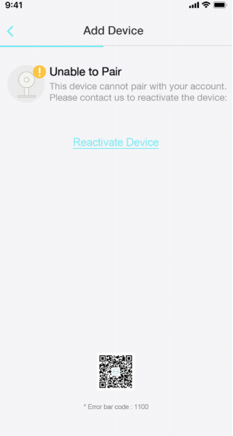

Indicators

Sense-U App at a Glance
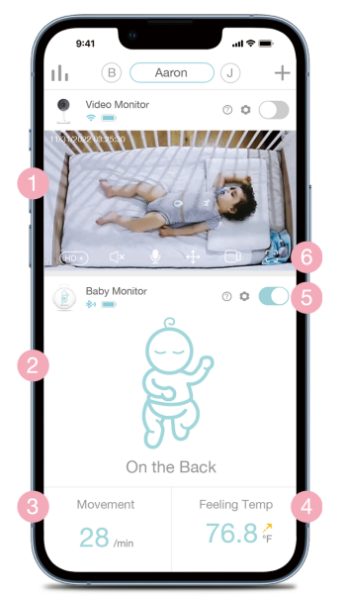

1.Video Section
•HD/SD: high/standard video quality
- Sleeping Position: measured sleeping position
- Movement
- < 5/min: slow movement detected
- --(dash): no movement or wiggle movement detected
1.Feeling Temperature: measured feeling temperature around child’s abdomen when the temperature hole is towards the air
•F/C: unit can be switched between ℃ and ℉
1.On/Off Button
- On: All baby notifications switched on
- Off: All baby notifications switched off, entering power-saving mode.
1.Video Functions
- Mic: Enable it to talk
- Speaker: Enable it to hear
- Record: Enable it to record video clips
- Fullscreen: Switch to full screen mode
* For audible notifications, notifications need to switch on for the Sense-U Baby app in Settings-
>Notifications->Sense-U Baby. For Android device, make sure Media Volume is switched on in
Settings->Sounds and Vibration->Volume. For iOS device, make sure your mobile device is not in
Do Not Disturb mode.
* For two-way audio, please turn on camera and microphone permissions in Settings->Apps-
>Sense-U Baby->Microphone and Camera and tap speaker and microphone icons in the app to
enable it.
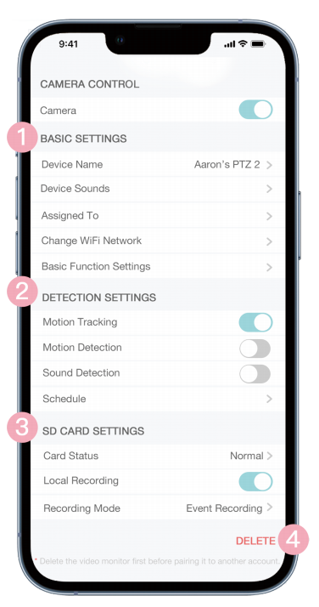
1.Basic Settings
- On / Off Button: Enable it to enter private mode
- Device Name: The name of your device
- Assigned To: A child, a nursery room, or any object that the device is used to monitor, or the location where the device is located
- Status Indicator: Status light
- Change Wi-Fi Network: Update Wi-Fi UUID or password
- Flip Screen: Rotate screen
- Time Watermark: Timestamps
- IR Night Vision: Automatic / On / Off
1.Motion Detection Settings
- Motion Detection: Get notified when motion is detected
- Sensitivity Level: the higher the level, the smaller motion can be detected
1.Storage Card Settings
- Card Status: Normal / Abnormal / Unavailable
- Local Recording: Enable it to allow local storage and video replay (up to 128Gb high speed micro SD card is supported)
- Recording Mode: Event Recording / Continuous Recording
1.Delete: Delete a connected device
* To pair a connected Sense-U Video camera to a new account, you need to delete it first by tapping “Delete” button.

TROUBLESHOOTING

The indicator light keeps flashing green and was unable to pair
If the indicator light keeps flashing GREEN after pairing, most likely the Wi-Fi password you entered or network connection is not right. Restart the power of your device until the indicator light changes to flashing RED and try again.

What’s the Wireless Range?
The Wi-Fi distance between Sense-U Video camera and your router can be up to 300 feet (92 meters) depending on your home router and the conditions of the room. You can check the video on mobile device from anywhere, as long as cellular data network is available.

The indicator light is in solid green after pairing but I received timeout error
Log out and log in again to update the status of the device.

The device cannot connect to my Wi-Fi network.
Make sure the Wi-Fi password you entered is correct and the network connection is good. Move the device and mobile device closer to the router and try again. Only 2.4GHz private Wi-Fi networks are supported (Hotspot Wi-Fi and 5GHz Wi-Fi networks are not supported).

The indicator light is in solid green when I pair it to a new Sense-U account
To pair a connected Sense-U Video device to a new account, you need to delete it first by tapping “Delete” button from the Sense-U Baby App->Video Device Settings (setup icon on the home page)->Delete first. Alternatively, you can press the Reset Button on the back of the device using a reset pin until the device starts to beep, and try again.

I got “unable to pair” error with a bar code
For security purpose, to pair a connected device to a new Sense-U account, the device needs to be removed from current account first by tapping the Sense-U Baby App->Video Device Settings (setup icon on the home page)->Delete. Send us an email with the error bar code you received to reactivate the device.

There is no audible notification when notification goes off
To receive audible notifications, notifications need to switch on for the Sense-U Baby app in Settings->Notifications->Sense-U Baby. For Android device, make sure Media Volume is switched on in Settings->Sounds and Vibration ->Volume. For iOS device, make sure your mobile device is not in Do Not Disturb mode.

I cannot hear or speak to my child in the Sense-U Baby app.
For two-way audio, please turn on the camera and microphone permissions in Settings->Apps->Sense-U Baby->Microphone and Camera and tap the speaker and microphone icons in the app to enable it.

DISCLAIMER
The Sense-U Video camera, and the Sense-U Smart Baby Monitor are not medical devices and are not intended for use in the diagnosis of disease or other conditions, or in the cure, mitigation, treatment, or prevention of disease. Customers use this device at their own risk and Sense-U Inc., its members, employees, agents, contractors, representatives, manufacturers, distributors and associates shall not be held liable for any loss, damage or injury suffered by the customer or any other person arising from, or in connection with, the use or manufacture of the device, including loss, damage or injury suffered by the customer or any other person as a result of any defects in respect of the monitor, and all warranties, and any other liability from whatsoever cause arising, are hereby excluded and the customer hereby indemnifies Sense-U Inc. in respect of any such liability.

GUARANTEE
Sense-U promises a 30-day Money Back Guarantee for this product and a 1-year Limited Warranty from the original date of purchase, verified by a sales receipt. Our warranty liability shall be limited to replacing the unit free of charge and does not include transport costs. Our guarantee extends to all countries in which this product is supplied. By the act of operating this product, the user accepts all resulting liability. We reserve the right to modify the provisions of this guarantee at any time without notice. This guarantee does not cover the battery, incorrect application, tampering, misuse or transport damage.

Sense-U Video Camera: Pairing Issues

Steps to troubleshoot pairing issues:
- Make sure the selected WiFi network is 2.4G private WiFi network, and is not a public WiFi network requiring credential login on a web portal like the ones at airport.
2. Verify the entered Wi-Fi password is right.
- If the indicator is flashing RED and GREEN, it implies weak Wi-Fi signal or crowded network situation. Move your Sense-U device close to your Wi-Fi router and make sure you are able to connect to internet.
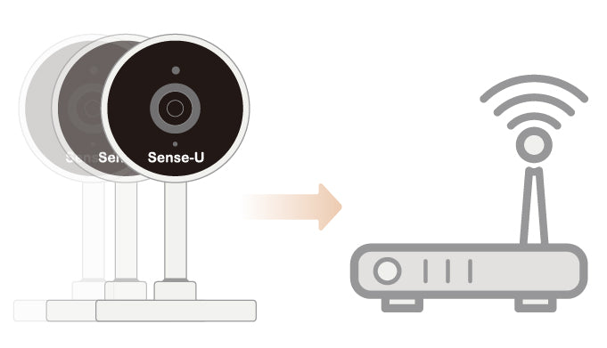
- If the indicator light is solid GREEN after pairing, but the App doesn't stream video as expected, please log out and log in again to reload the video stream.
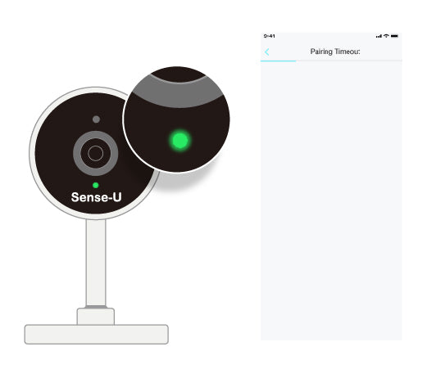

"Unrecognized QR code" Error:
- Make sure the selected Wi-Fi network is 2.4G private Wi-Fi network, and is not a public Wi-Fi network requiring credential login on a web portal like the ones at airport.
- Ensure the lens is not blocked and clean. Move to a brighter place and adjust the brightness of your smartphone to maximum. Place the app QR code in front of the video camera at a distance of 6”-12”(15cm-30cm). Adjust the angle and distance until you hear a prompt.
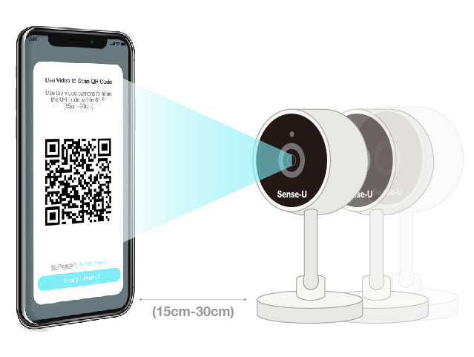
- Alternatively, try Auto Scan method: “Try Auto Scan ->” (Available for iOS App now)
- If you are using a Wi-Fi 6 router with single network ID (SSID), make sure to unselect "SMART CONNECT" from your router's web interface or app, and then choose the 2G SSID to pair:
(e.g: TP-Link Tether App)
Tips: Where to find Smart Connect for typical routers:
- Tp-Link Wi-Fi 6: https://www.tp-link.com/us/support/faq/2595/
- Netgear Wi-Fi 6: https://kb.netgear.com/25346/
- Amazon Eero - Temporarily pause 5GHz: https://support.eero.com/hc/en-us/articles/115005497223/
- Aus Wi-Fi 6: https://www.asus.com/us/support/FAQ/1012132/

"Unable to pair" Error with an error bar code:
- Follow the instruction and send us the bar code image.
- Allow 1 business day for us to unlink the camera from your account.
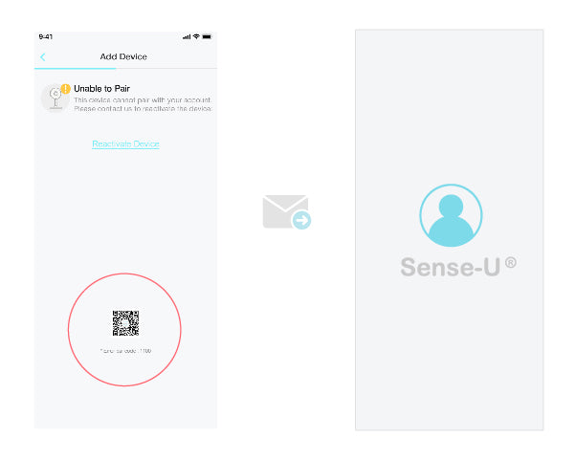
- Add the camera again to your account from the Sense-U app->Setup-> Add Device or the Sense-U app->Setup->Manage Devices->+.
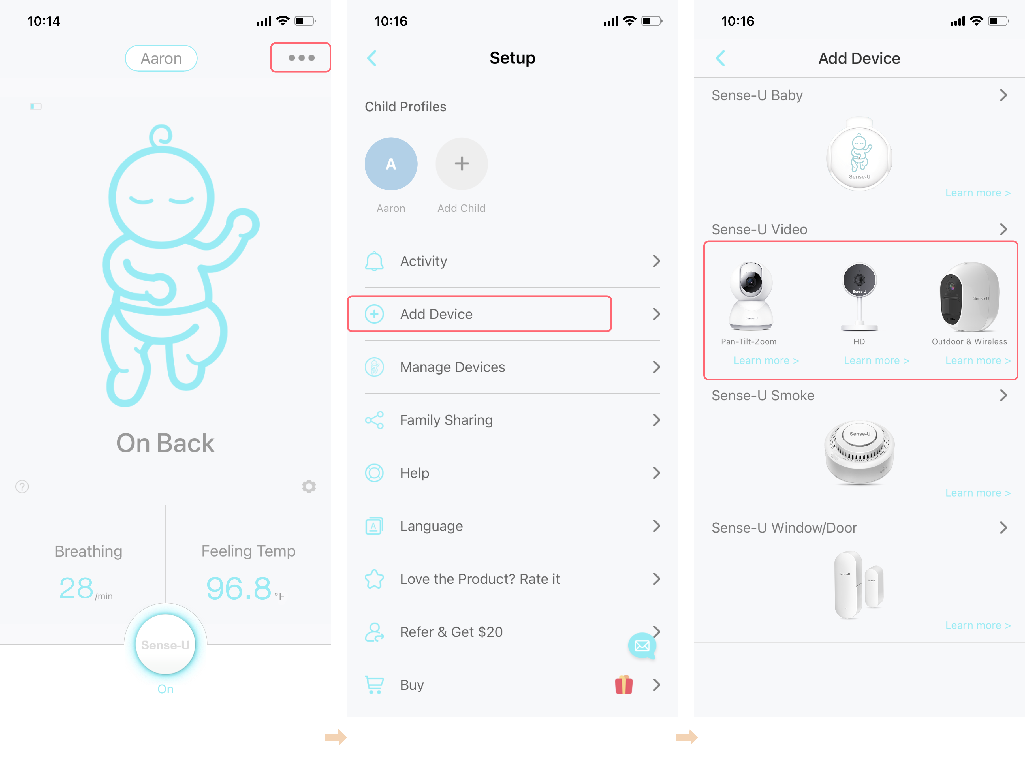

"Account already exists" Error:
- Register the Sense-U Baby(New) app with a NEW email ID.
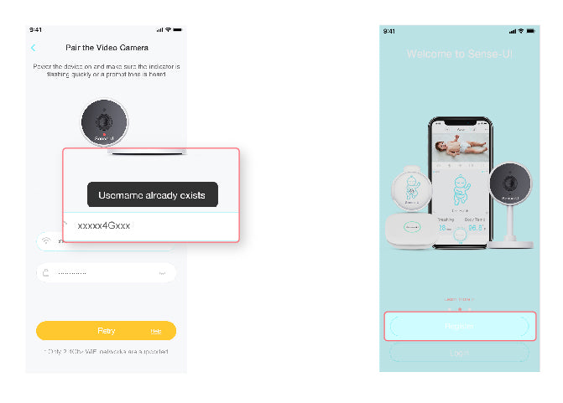
2. Send us the error bar code image together with your NEW email ID.
3. Allow 1 business day for us to unlink the camera from your old account.
- Add the camera again to your new email ID.
* If still no luck, refer to the latest user manual or contact us from the Sense-U App->Setup->Help->Feedback.

Sense-U Video Camera: Connection Issues

Steps to troubleshoot connection issues:
- Move your Sense-U device close to your WiFi router and make sure you are able to connect to internet.
2. Verify the WiFi password has not been changed recently.
- Switch your smartphone to cellular plan to see if it is able to stream the video.

- If the indicator light is solid RED, it means the camera is not able to connect to internet. Check your network connection and WiFi password.
5. If still not working, delete the camera from your current account and register the latest iOS app(3.1.2) with a NEW email address to pair the camera again. It will connect your camera to a closer server to improve connection performance.

Sense-U Video Camera: Connection Issues
- years ago Updated
FollowNot yet followed by anyone

Steps to troubleshoot connection issues:
1. Move your Sense-U device close to your WiFi router and make sure you are able to connect to internet.
2. Verify the WiFi password has not been changed recently.
- Switch your smartphone to cellular plan to see if it is able to stream the video.

- If the indicator light is solid RED, it means the camera is not able to connect to internet. Check your network connection and WiFi password.
5. If still not working, delete the camera from your current account and register the latest iOS app(3.1.2) with a NEW email address to pair the camera again. It will connect your camera to a closer server to improve connection performance.

* If still no luck, refer to the latest user manual or contact us from the Sense-U App->Setup->Help->Feedback.

